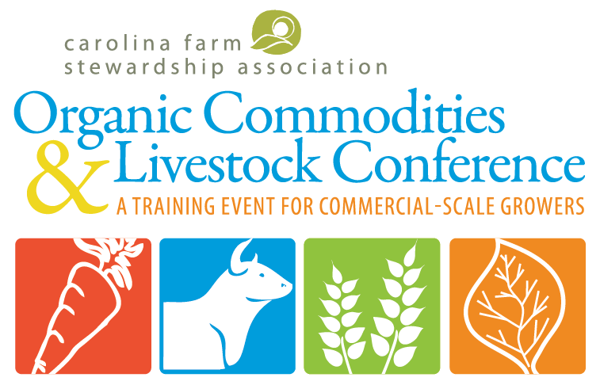
A Training Event for Commercial-Scale Growers
Monday, March 6, 2017/ Mount Olive, NC

SPONSOR AND EXHIBITOR PACKAGES
The Carolina Organic Commodities & Livestock Conference (OCLC) is the Carolina Farm Stewardship Association’s annual training event for commercial-scale growers. The 7th annual OCLC event will be held on Monday, March 6th, 2017 in the Agribusiness School at the University of Mount Olive, in Mount Olive, NC.

The OCLC draws together almost 200 leaders in the organic commodities and livestock sector, presenting an opportunity for sponsors and vendors to have meaningful interactions with a highly targeted niche audience of commercial scale growers, extension agents, educators, agronomists, certifiers, and organic input suppliers. Your company or organization will also benefit from print advertising and web and social media recognition.

KEYNOTE SPEAKER
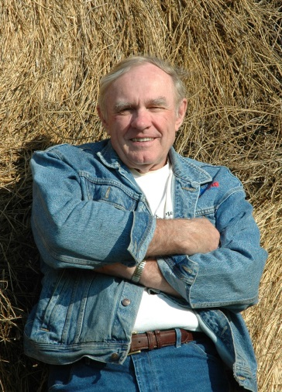
Fred Kirschenmann
In 1976, Fred converted his family’s 1,800-acre farm in North Dakota to a certified organic operation, developing a diverse crop rotation that has enabled him to farm productively without synthetic inputs while simultaneously improving the health of the soil. His farm has been featured in numerous publications including National Geographic, Business Week, Audubon, the LA Times and Gourmet magazine and he is the author of the book of essays, Cultivating an Ecological Conscience: Essays from a Farmer Philosopher. His appointments have included Distinguished Fellow at the Leopold Center for Sustainable Agriculture and professor in the Department of Religion and Philosophy at Iowa State University, Board President of the Stone Barn Center, member emeritus of the USDA's National Organic Standards Board and the National Commission on Industrial Farm Animal Production.

CONFERENCE WORKSHOPS
Fifteen workshops will be offered (full details available February 6th). Workshop topics will include a variety of subjects including organic grains, livestock and grazing, pork production, sweet potatoes, dairy cattle, high tunnel utilization, and organic certification.

The OCLC conference schedule also features a 30-minute vendor-producer networking session dedicated solely to networking between participants and vendors.

SPONSOR AND EXHIBITOR PACKAGES
 | Keynote Sponsor - $2,500 | Conference Shepherd -  $1,000 | Conference Sustainer -  $500 | Conference Exhibitor -  $200
Special Recognition
Keynote Sponsor Recognition at Keynote Luncheon | X
Opportunity to include materials in conference attendees registration packet | X
Complimentary one-year CFSA Business Membership | X
Exhibit Space
Complimentary Exhibit Space with prime front-door location | x
Complimentary Exhibit Space |  | x | x | x
Conference Registration and Meals
Complimentary conference registration, light breakfast, and keynote luncheon | 4 | 3 | 2 | 1
Additional conference registration, light breakfast, and keynote luncheon | $35 | $35 | $35 | $35
Conference and Media Recognition
Placement of company logo on promotional emails | X | X
Mention in all media releases | X | X
Listing in CFSA Annual Report | X | X
Logo in video highlight at conference | X | X | X
Logo on conference website with link to sponsor website | X | X | X
Recognition in Conference Program | Featured | X | X | X
EXHIBITOR TERMS AND CONDITIONS
EXHIBIT SCHEDULE 7:30 am – 8:30 am Set-up
9:00 am – 4:00 pm Exhibit Hall Open
10:30 am – 11:00 am Exclusive Exhibitor Networking Session
4:00 pm Conference Ends
EXHIBIT SPACE ASSIGNMENT
Table assignments will be made by CFSA, priority will be given to sponsors and specific requests for placement will be honored to the best of our ability. We do not assign table numbers in advance, but will be available to escort exhibit staff to their assigned table. Exhibit space includes one 6’ by 30’’ table, one chair (additional chairs available on request), and complimentary wi-fi internet access. Electricity is available by request on a limited, first come first serve basis.

EXHIBITOR CANCELLATION
Cancellation of any portion of this Application/Contract by the Exhibitor will be accepted upon the following refund schedule: At least 75 days-5O% of contract. Less than 75 days-no refund. Except as the Exhibitor rental obligation may be reduced as set forth in the preceding sentence, the Exhibitor is responsible for total space rental irrespective of the reason for the cancellation by the Exhibitor or because of the failure of an Exhibit to arrive for any reason.

EXHIBITOR GUIDELINES
Exhibitors reserve the right to sell items for their business, nonprofit, or organization from their table. CFSA reserves the sole right to solicit donations from attendees. Please refrain from soliciting donations on behalf of your own, or another organization.

INDEMNITY AND LIMITATION OF LIABILITY
Neither CFSA nor the host Hotel/convention facility (hereinafter Exhibit Building), nor any of its officers, agents employees or other representatives shall be held liable for, and they are hereby released from liability for, any damage, loss, harm or injury to the person or property of the Exhibitor or any of its visitors, officers agents, employees or other representatives, resulting from their theft, fire, water or accident or any other cause. The Exhibitor shall indemnify, defend and protect CFSA and the Exhibit Building and hold CFSA and the Exhibit Building, harmless from any and claims, demands, suits, liability damages, loss, costs, attorney fees and expenses of any kind which might result from or arise of any action or failure to act on the part of the Exhibitor or its officers, agents, employees or other representatives. It is the responsibility of the Exhibitor to maintain proper insurance cover for its property and liability.
DEADLINES Friday, January 22
EARLY SPONSOR DEADLINE
Guaranteed listing in event promotional items and website
Friday, February 12
ALL SPONSOR/EXHIBITOR DEADLINE
Guaranteed listing in conference program
Friday, February 26
DEADLINE TO BUY ADDITIONAL TICKETS
LOCATION The University of Mount Olive
Mount Olive Pickle Conference Center/ Lois G. Britt Agribusiness Center
652 R.B. Butler Drive
Mount Olive, NC 28365

Free Parking is available outside the event center. Look for CFSA's Tomato Signs. Registration will be in the main lobby of the Agribusiness center.

Please complete the Sponsorship or Exhibitor Contract below and submit with payment.

Please email your high resolution, full color logos in GIF or PNG file format to
CFSA’s Communications Coordinator, Amy Armbruster at Amy@Carolinafarmstewards.org

Questions? Contact Stephanie Campbell at Stephanie@Carolinafarmstewards.org or 919-542-2402

SPONSOR AND EXHIBITOR CONTRACT

Please complete the Sponsorship or Exhibitor contract below and submit with payment.

For more information, contact Stephanie Campbell at stephanie@carolinafarmstewards.org or 919-542-2402

Full Company Name (as it should appear in listings): Click here to enter text.

Address: Click here to enter text.

City: Click here to enter text. State: Click here to enter text. Zip: Click here to enter text.

Phone: Click here to enter text. Website URL: Click here to enter text.

Contact Person Name: Click here to enter text.

Title: Click here to enter text.

Email: Click here to enter text.

Sponsor/Exhibitor Levels:
☐$2,500 Keynote Sponsor
☐$1,000 Conference Shepherd
☐$500 Conference Sustainer
☐$200 Conference Exhibitor

Exhibit Requests:
☐Electricity (available on a limited, first come first serve basis)
☐Extra Chair
☐Other special accommodations: Click here to enter text.

If your sponsorship includes an exhibit space, please let us know if you plan to utilize this benefit:
☐Yes, I plan to utilize our space
☐No, I do not need my exhibit space

Sponsor/Exhibitor Staff (if different than organization contact):
Name: Click here to enter text.
Email: Click here to enter text.
Title: Click here to enter text.
CONTINUE ON TO PAGE 2

Additional Attendee(s):
Name: Click here to enter text.
Email: Click here to enter text.
Title: Click here to enter text.

Name: Click here to enter text.
Email: Click here to enter text.
Title: Click here to enter text.

Name: Click here to enter text.
Email: Click here to enter text.
Title: Click here to enter text.

Total Due:
Sponsor/Exhibitor Level Selected above: Click here to add dollar amount
Attendees in Addition to Complimentary ($35/each) Click here to add dollar amount
☐ Check made out to CFSA enclosed (if mailing a check, please also email stephanie@carolinafarmstewards.org to put your exhibit or sponsorship on hold)
☐ Invoice me (CFSA will send invoice to the email address provided above)
☐ In-kind Donation - please confirm details of any in-kind donation with a brief description
Click here to enter text.
Credit Card Information
Account Number: Click here to enter text.
Exp. Date: Click here to enter text.
CVV/Security Code: Click here to enter text.
Signature: Click here to enter text.
Name on Card: Click here to enter text.
Billing Address (if different from Business address: Click here to enter text.

Please return completed form by email to stephanie@carolinafarmstewards.org , or by mail to:
Carolina Farm Stewardship Association
PO Box 448
Pittsboro, NC 27312

