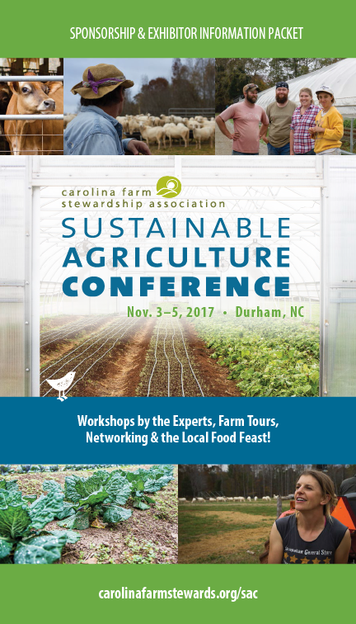
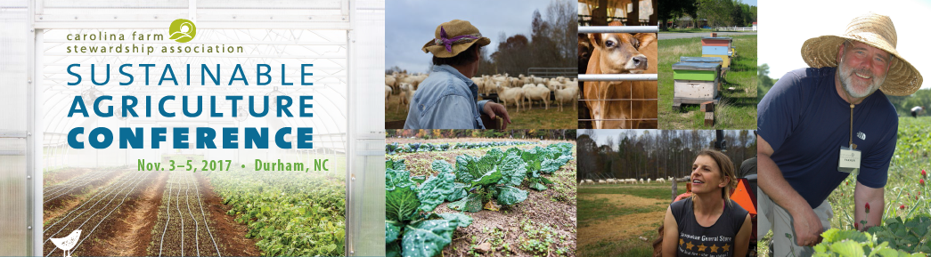

WHY SPONSOR THE 2017 SUSTAINABLE AGRICULTURE CONFERENCE?
Become a Sponsor and add your company name to those who are supporting the Conference!
The Sustainable Agriculture Conference is the best place to show your commitment to sustainable agriculture and to promote your product, brand, or service. Your company or organization will benefit with direct exposure and acknowledgement during the Conference, as well as gaining wide exposure through print advertising, newsletters, and web and social media recognition during the months leading up to and following the Conference.

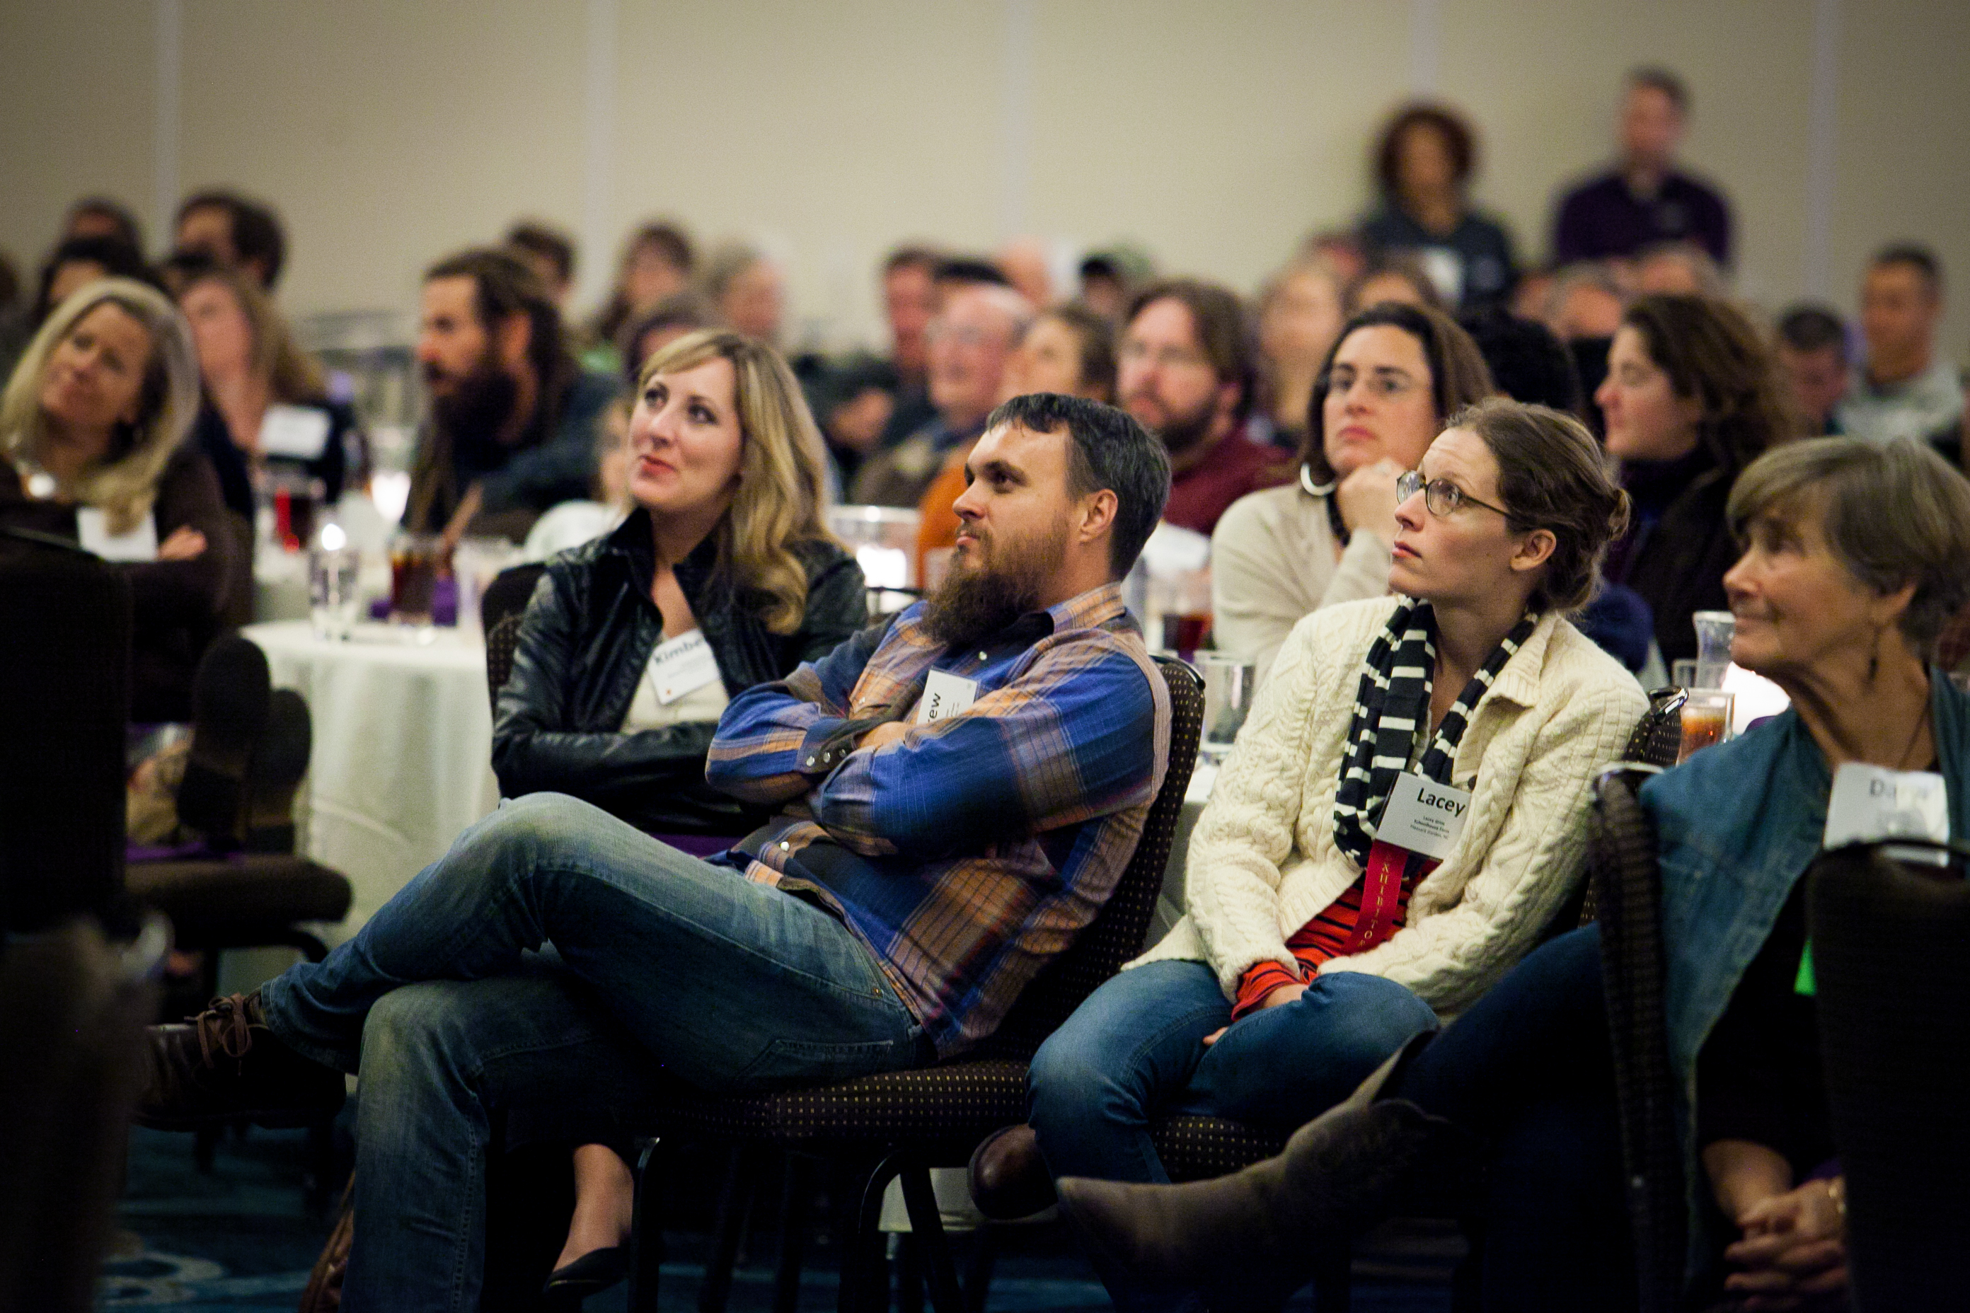
The Local Food Feast is always one of the highlights of the Conference, featuring amazing local,
organic food, a thought-provoking keynote, and presentation of the Farmer of the Year awards.

ABOUT THE CONFERENCE
The Carolina Farm Stewardship Association’s (CFSA) Sustainable Agriculture Conference is the premier food and farming conference in the Carolinas. The Sustainable Agriculture Conference brings together those new to the movement along with experienced veterans to connect and collaborate. We expect more than 1,200 individuals in attendance this year - a vibrant network of farmers, producers, consumers, activists, foodies, educators, and members of related businesses and organizations.
The three-day Conference includes:
- Pre-conference farm tours and intensive learning opportunities.
- More than 60 workshops in tracks such as Beginning Farmer, Soils, Livestock, Horticulture, and Policy.
- 70 exhibitors.
- Local and organic meals.
- Networking opportunities - regional and topical meetings, buyer/producer meet-up, seed exchange, Meet and Eat Reception, and more.

2017 CONFERENCE KEYNOTE: Atina Diffley
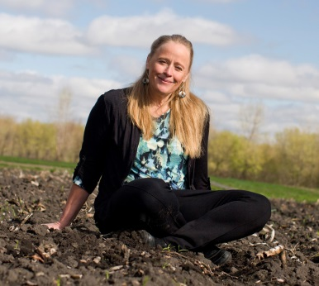
Atina Diffley is an organic farmer, activist, public speaker, and author of the 2012 award-winning memoir, Turn Here Sweet Corn: Organic Farming Works. From 1985 to 2008, she and her husband, Martin, ran the Gardens of Eagan, an urban-edge, organic vegetable farm, which he started in 1973 as one of the first certified organic produce farms in the Midwest.
In 1989, the 5th-generation Diffley family land was lost to suburban development. The Diffleys started over on new land, but faced eminent domain again in 2006 when threatened by a crude oil pipeline owned by Koch Industries. Atina successfully led a legal and citizen campaign against the notorious polluters that lead to the creation of an Organic Mitigation Plan that provides protections for the soil and certification of threatened organic farms in Minnesota.
SPONSORSHIP PACKAGES
SPONSOR BENEFITS | Sustainer - $10,000 | Harvester - $5,000 | Seed Sower - $4,000 | Educator - $3,000 | Wi-Fi Connector - $2,500 | Cultivator - $2,000 | Pollinator - $1,000 | Grower - $500 | Food Sponsor – $500+ value | Media Sponsor – In-kind
Special Recognition (see descriptions on next page)
Keynote Sponsor | X
Awards Sponsor |  | X
Meet and Eat Reception Sponsor |  |  | X
Educational Track Sponsor |  |  |  | X
Wi-Fi Connector Sponsor |  |  |  |  | X
CFSA Business Membership
(see NEW benefits on next page)
Complimentary | X | X | X | X | X | X
Conference Program Book
Full-page ad | X
Half-page ad |  | X | X
Quarter-page ad |  |  |  | X | X | X
Listing |  |  |  |  |  |  | X | X | X | X
Exhibit Space
Complimentary | X | X | X
Conference Registration including Meal Package
Complimentary for top sponsors | 4 | 3 | 2 | 2 | 1 | 1 | 1
Other Benefits
Early Bird - Conference Brochure Recognition | * | * | * | * | * | * | * | * | * | *
Conference Press Releases - Mentioned in all | X | X
CFSA 2017 Annual Report – Recognition | X | X | X | X | X | X | X
Conference Email Promotions – Logo Recognition | X | X | X | X | X | X | X
Conference Video Reel – Logo Recognition | X | X | X | X | X | X | X
Conference Webpage - Logo Link | X | X | X | X | X | X | X
Conference Video Reel – Listed Recognition |  |  |  |  |  |  |  | X | X | X
Conference webpage – Listed Recognition |  |  |  |  |  |  |  | X | X | X

TOP SPONSOR OPPORTUNITIES
Keynote Sponsors – Sustainer $10,000
The Keynote Sponsors will be specially recognized from the podium at the Friday evening Local Food Feast. This kick-off event of the conference features an amazing menu of local food, the keynote address by Atina Diffley, and awards presentation of the Farmer of the Year and Beginning Farmer of the Year.
Awards Sponsors – Harvester $5,000
The Awards Sponsors will be specially recognized from the podium at the Saturday Awards Luncheon. The William W. Dow Scholarship recipients will be honored and awards will be given to institutions and individuals who have made outstanding contributions to the sustainable food movement.
Meet and Eat Reception Sponsors – Seed Sower $4,000
The Meet and Eat Reception Sponsors will be specially recognized with placards at the buffet tables at this Saturday evening informal mixer featuring delicious heavy hors d’oeuvres and local wine and beer.
Educational Track Sponsors – Educator $3,000
The Educational Track Sponsors will be recognized with their logo and contact information on a half-page “notes page” in the Conference Program for participants to take home with them.
Wi-Fi Connector Sponsor – $2,500 *Only ONE Sponsorship Available*
The Wi-Fi Connection Sponsor will be recognized for providing free Wi-Fi to all conference participants. When a conference participant logs in to the Wi-Fi, the landing page will say, “Free Wi-Fi provided by YOUR COMPANY NAME.”

SPECIAL BENEFITS
Business Membership
One-year complimentary Business Memberships will be granted at the following levels: $10,000 sponsors receive Business Shepherd Membership ($500 value); $4,000+ sponsors receive Business Cultivator Membership ($250 value), and $2,000+ sponsors receive Business Supporter Membership ($100 value).
Business members will be listed on the new CFSA Business Directory webpage with a description of your business and a link to your web site. Business Membership benefits also include:

- Event discounts
- Early invite to sponsor and exhibit
- Web calendar listings
- Membership directory access
- Voting privileges at our annual meeting
- Subscription to eNewsletters
- Listserv to network with members
- Resource referral
- Job board posting, a $60 value
- Access to Business Development Services
- Window cling for storefront

Early Bird Conference Brochure Recognition
Sponsors who make a commitment and return a signed Sponsor Agreement Form by the June 30th Early Bird Deadline will receive additional promotion and acknowledgment in the Conference Brochure, which is mailed to over 3,000 CFSA members and widely distributed across the Carolinas.

EXHIBITOR PACKAGES
EXHIBIT PRICES  New! All exhibit spaces include free Wi-Fi. | Business | Non-Profit
Premium  Adjacent to Imperial Ballroom | $380 | $305
Empire  Adjacent to Empire Ballroom | $355 | $255
Bull Durham  Room with floor length windows facing main hallway | $290 | $190

EXHIBITOR SPACE MAP
Exhibitors may select space in one of three general areas, shown on the map below.
See Exhibitor Terms and Conditions Packet for details.
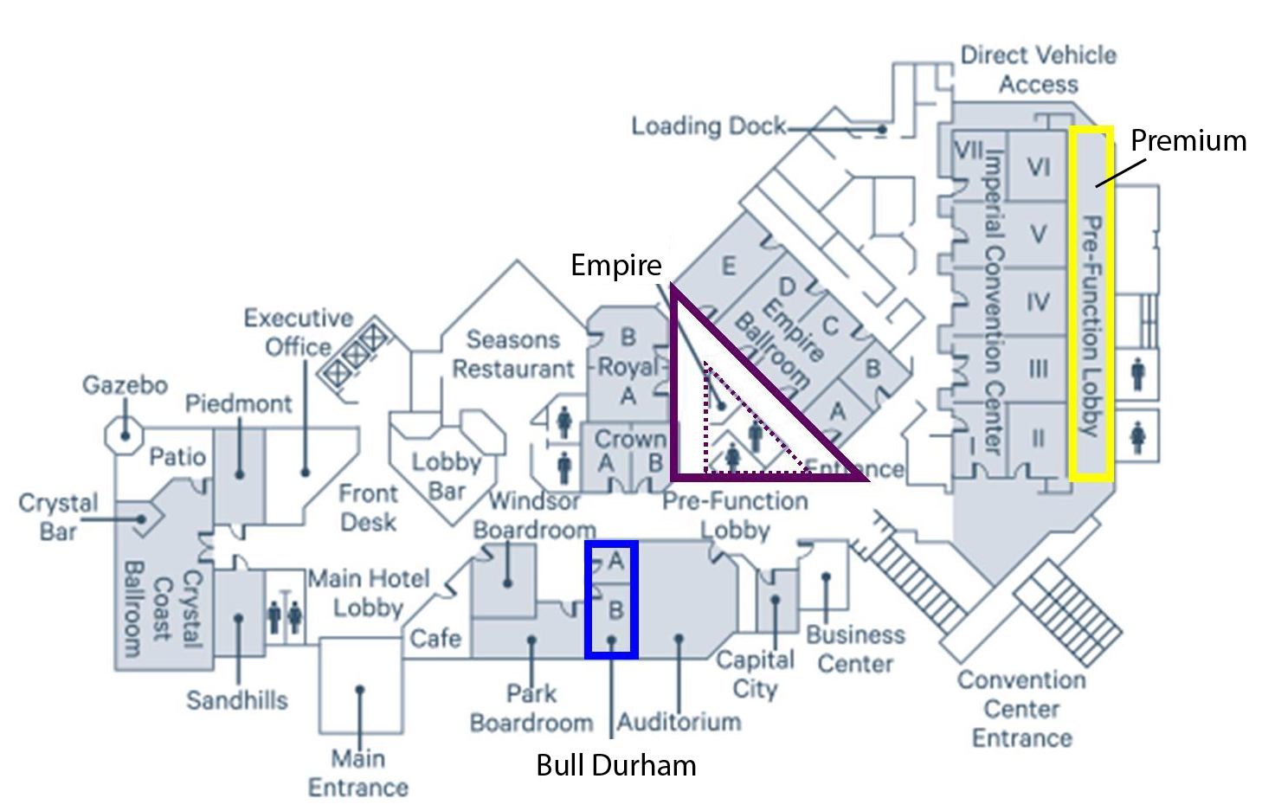

SPONSOR AND EXHIBITOR DEADLINES
FRIDAY, JUNE 30, 2017
EARLY SPONSOR DEADLINE
Guaranteed listing in Conference Brochure
FRIDAY, SEPTEMBER 29, 2017
SPONSOR CONTRACT DEADLINE
Guaranteed listing in Conference Program
$50 LATE FEE APPLIES TO CONTRACTS COMPLETED AFTER THIS DATE
FRIDAY, OCTOBER 13, 2017
EXHIBITOR CONTRACT DEADLINE
A $50 LATE FEE APPLIES TO CONTRACTS COMPLETED AFTER THIS DATE
FRIDAY, OCTOBER 27, 2017
DEADLINE TO REGISTER & PURCHASE ADDITIONAL TICKETS
EXHIBITOR LATE CONTRACT DEADLINE (ADDITIONAL $150 LATE FEE APPLIES)
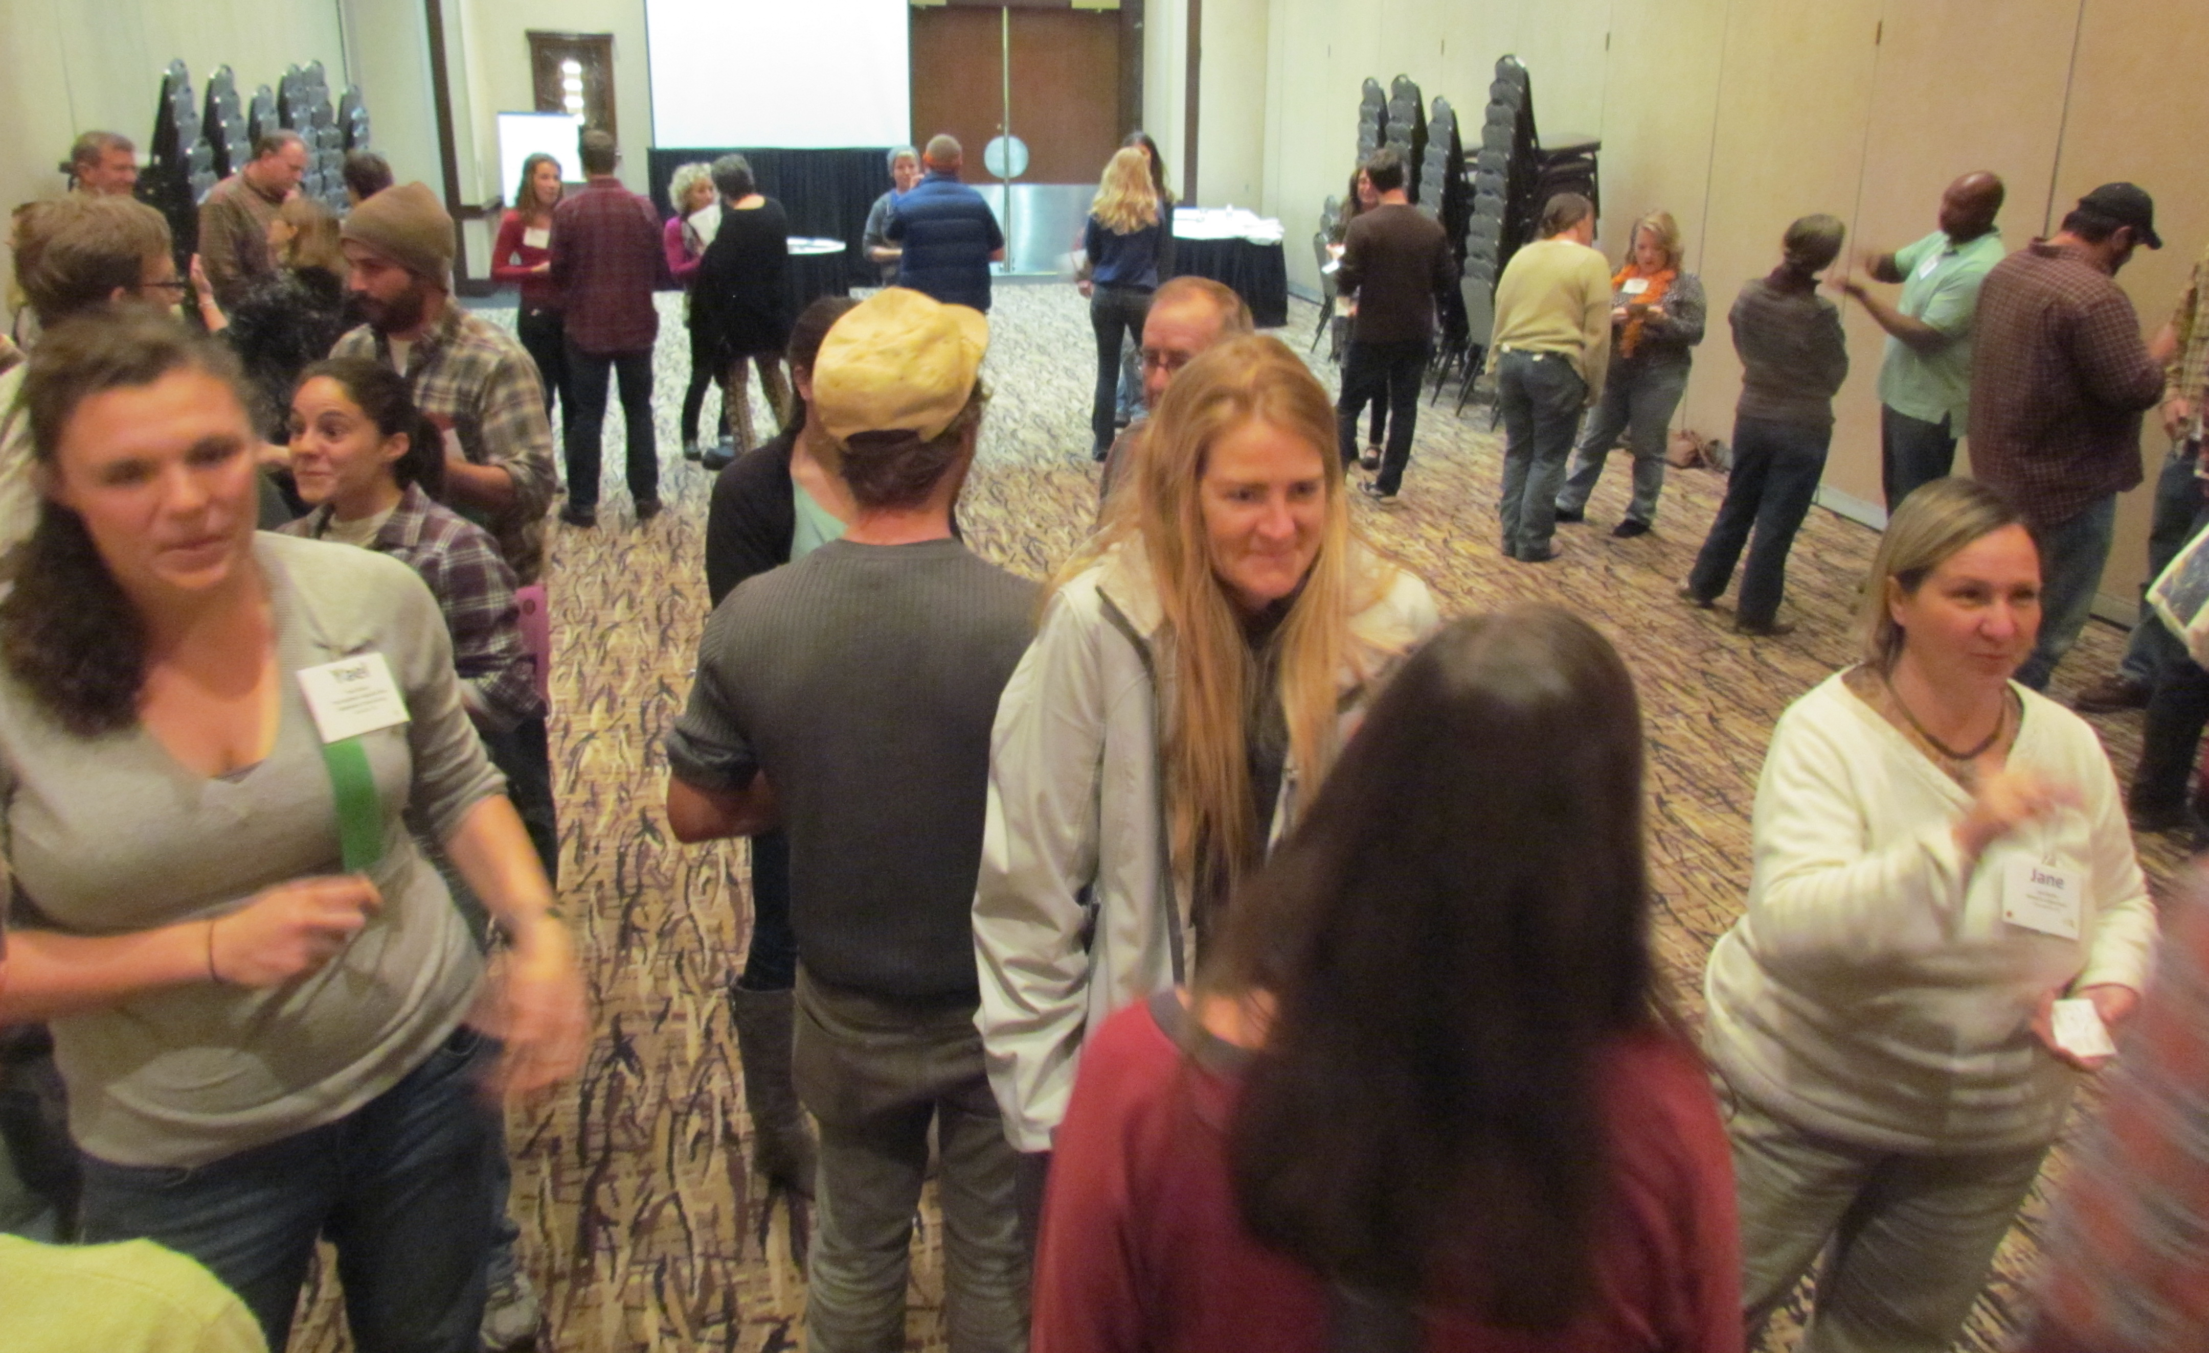

The Conference offers ample opportunities to meet and network, including Speed Networking,
themed tables at meals, and during long breaks between sessions.
SPONSOR & EXHIBITOR AGREEMENT FORM
Full Company Name (as it should appear in listings): Click here to enter text.

Contact Name: Click here to enter text.
Attending? ☐ YES ☐ NO

Title: Click here to enter text.
Mailing Address: Click here to enter text.
Phone: Click here to enter text. Email: Click here to enter text.
Company/Organization Website: Click here to enter text.
Additional Attendees:

Contact Name: Click here to enter text.
Title: Click here to enter text.
Email: Click here to enter text.

Contact Name: Click here to enter text.
Title: Click here to enter text.
Email: Click here to enter text.

CASH SPONSORS
Please select the level at which you wish to sponsor:

☐ Sustainer ($10,000)
☐ Harvester ($5,000)
☐ Seed Sower ($4,000)
☐ Educator ($3,000)
☐ Wi-Fi Connector ($2,500)
☐ Cultivator ($2,000)
☐ Pollinator ($1,000)
☐ Grower ($500)

IN-KIND SPONSORS
Please confirm in-kind arrangements in advance with Elizabeth Read,
CFSA Communications and Development Director: elizabeth@carolinafarmstewards.org
☐ Food Provider – please describe: Click here to enter text.
☐ Media Provider – please describe: Click here to enter text.
☐ Other – please describe: Click here to enter text.
EXHIBIT SPACE
COMPLIMENTARY WITH SPONSORSHIP
For sponsors of $4,000+, will you be utilizing the complimentary premium exhibit space?
☐ Yes ☐ No

FOR PURCHASE
- Please select the level at which you wish to exhibit:

☐ Premium, Business ($380)
☐ Premium, Non-Profit ($305)
☐ Empire, Business ($355)
☐ Empire, Non-Profit ($255)
☐ Bull Durham, Business ($290)
☐ Bull Durham, Non-Profit ($190)

- Would you like to add electricity to your exhibit space?
☐ Electricity ($25)
- Comments or Requests? Let us know if you have specific arrangement requests - we will do our best to accommodate them. Click here to enter text.
- Tax ID Number (For Non-Profits only): Click here to enter text.
- Please provide a brief description of your company/product/organization: Click here to enter text.
CONTINUE TO PAGE 2 >>>>>>>>>>
SPONSOR & EXHIBITOR AGREEMENT FORM
Please send a signed copy of this agreement to: partners@carolinafarmstewards.org
OR BY MAIL:
Carolina Farm Stewardship Association
PO Box 448, Pittsboro, NC 27312
PAYMENT
Exhibitor space assignments will not be made until full payment is received.
Payment Options:
☐ Check enclosed made payable to: Carolina Farm Stewardship Association
☐ Visa/MasterCard/American Express/Discover
☐ Invoice me (CFSA will send invoice to the email address provided in contact name above)
Credit Card Information:
Account Number: Click here to enter text.
Exp. Date: Click here to enter text. CVV/Security Code: Click here to enter text.
Name on Card: Click here to enter text.
Billing Address (if different from Business address): Click here to enter text.
I have read and agree to the Sustainable Agriculture Conference Sponsor and Exhibitor Guidelines.
_____________________________________________________________________
Signature
If submitting contact electronically, please include: “I approve this contract” in your email text.

SPONSOR PROMOTION GUIDELINES
Send files to: amy@carolinafarmstewards.org
Immediately Company or Organization Logo
Please send a high resolution PDF and web-ready GIF format logo for promotion on the CFSA website, social media, and Conference highlight video reel.
Sept. 30, 2016 Conference Program Book Ad
Please send a PDF format, black & white or grayscale ad.
Full Page 8 ½” x 11” Sustainer ($10,000)
Half Page 4.75” x 7” Harvester ($5,000) and Seed Sower ($4,000)
Quarter Page 3.25” x 3.25” Educator ($3,000), Wi-Fi Connector ($2,500) and Cultivator ($2,000)

